Unit 6 Website Development

Assignment 1

Oliver Collins-Cope

2022

Table of Contents

**No table of contents entries found.**

# Introduction

Throughout this assignment I will be discussing two different websites, Facebook and Twitter, and describing how they differ, comparing them based on different points such as usability, layout, navigation, content, readability, typography, accessibility, consistency and many more. These sites will be compared, analysed, and evaluated in order to determine how well they operate under the principles of website design in order to produce a fully functional and smooth experience for the user.

# Facebook

Facebook is a social media giant, remaining at the forefront of social media and is one of the most used websites, while also being the most used social media website by roughly 600 million users (Statista Research Department, 2022).

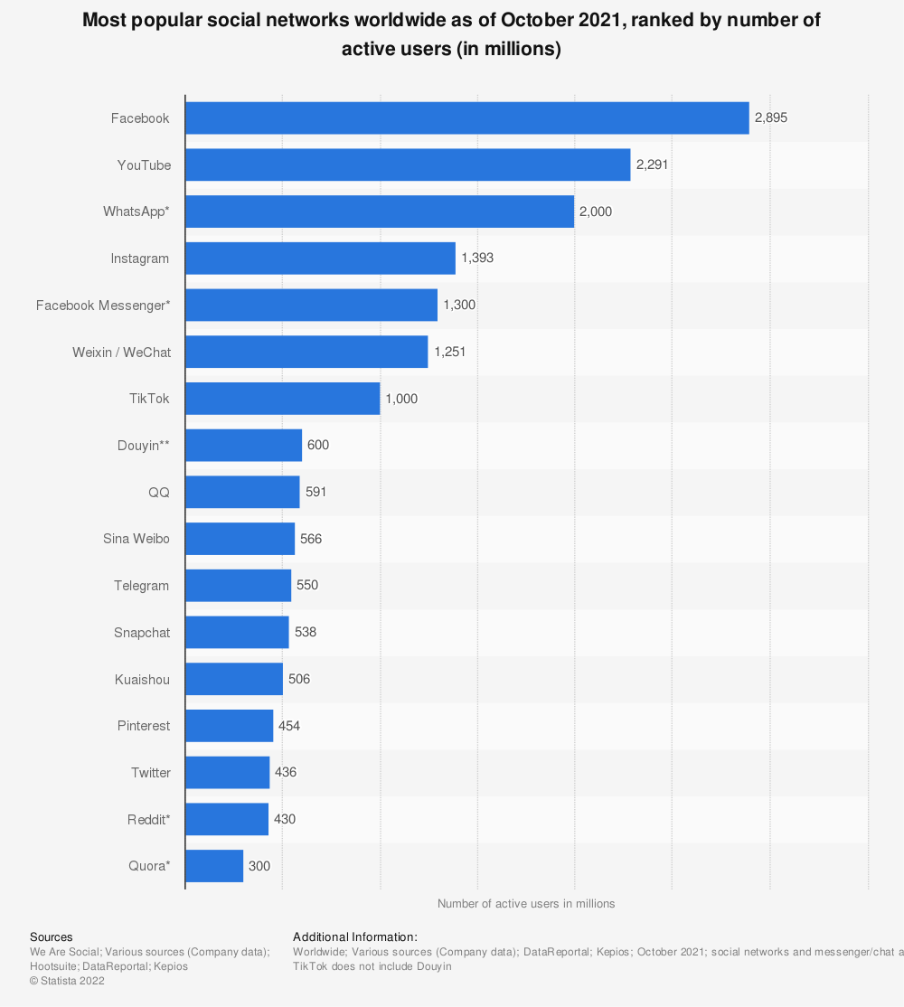

Facebook, being a social media platform, its primary purpose, for users, is to allow them to connect and interact with each other online, while also allowing users to view content for different pages they might follow, post their own content and statuses, as well as small games that the website supports - this last feature is unique to Facebook. Facebooks target audience are those in their mid-20’s to mid-30’s, as this is the most active Chart, bar chart
age group on Facebook by about 6% for males, and 3% for females.

When loading Facebook, users are presented with their homepage with presents users with an opportunity to browse their latest feed, upload their own statuses, and comment and like on different posts. Graphical user interface, application

It has the option of quickly accessing chats on the right, which is convenient for the user and short cuts to different things like games on the left.

## Usability

The usability of Facebook has been highly optimised since its release in 2004, with Facebook being supported on a multitude of browsers, and available on other browsers that are not openly supported. Some examples of the browsers supported by Facebook include Google Chrome, Mozilla Firefox, Safari, and Microsoft Edge. (Facebook, 2022)

The different browsers load Facebook as shown below:

Google Chrome

Microsoft Edge

Mozilla Firefox

Safari

Across all the sites, they load all quickly and without an issue once the user is logged in and presents a smooth experience for the user to browse freely.

This also leads into another website design principle:

## Consistency

Across multiple browsers, Facebook remains consistent, with its design and layout remaining the same, as seen in the screenshots above. This is key as consistency in websites leads to users developing a sense of comfort and stability on the website, no matter what browser is being used.

It is important to note that the example using safari was done with an incomplete account and would otherwise load the same as all the other browsers, as seen here.

(Fix, 2022)

## Accessibility

Facebook has several accessibility options available to all users. These are made very clear to the user through a simple google search about them, upon which it brings users to a page all about the available options.

These options include:

* Keyboard shortcuts
* Screen readers
* Voiceover technology
* Closed captions (Subtitles) on videos
* Text size
* Text contrast

These options are shown as below.

Keyboard shortcuts

The keyboard shortcuts allow users to navigate without the use of a mouse and solely a keyboard.

Screen readers

The screen readers allow for those with visual impairments that prevent them from seeing the website, navigate it and access it without the use of their eyes.

Subtitles

Subtitles enable users to watch videos and understand the content without having to hear or listen to them, which can greatly help users that struggle with hearing disabilities and issues.

Text size and text contrast

These adjustments enable users to see things more clearly that they might not have been able to see and can help users who might have issues with differentiating colours, such as those who are colour blind.

## Layout

The layout of the Facebook website remains clear and uncluttered. This is crucial as having a simpler design where the content of the website and elements of it are spread out and easy to differentiate significantly boost user experience and mean a higher chance of users coming back to reuse the site.

The overall layout of Facebook remains simple, with things clearly either labelled or displayed with symbols that are easy to infer and understand, like the TV screen displaying videos, and the shortcuts and contacts clearly labelled on the sides. The content of the actual home feed is clearly separated from the sides using white space, to avoid making the site look more cluttered and giving the user a more pleasant experience using the site.

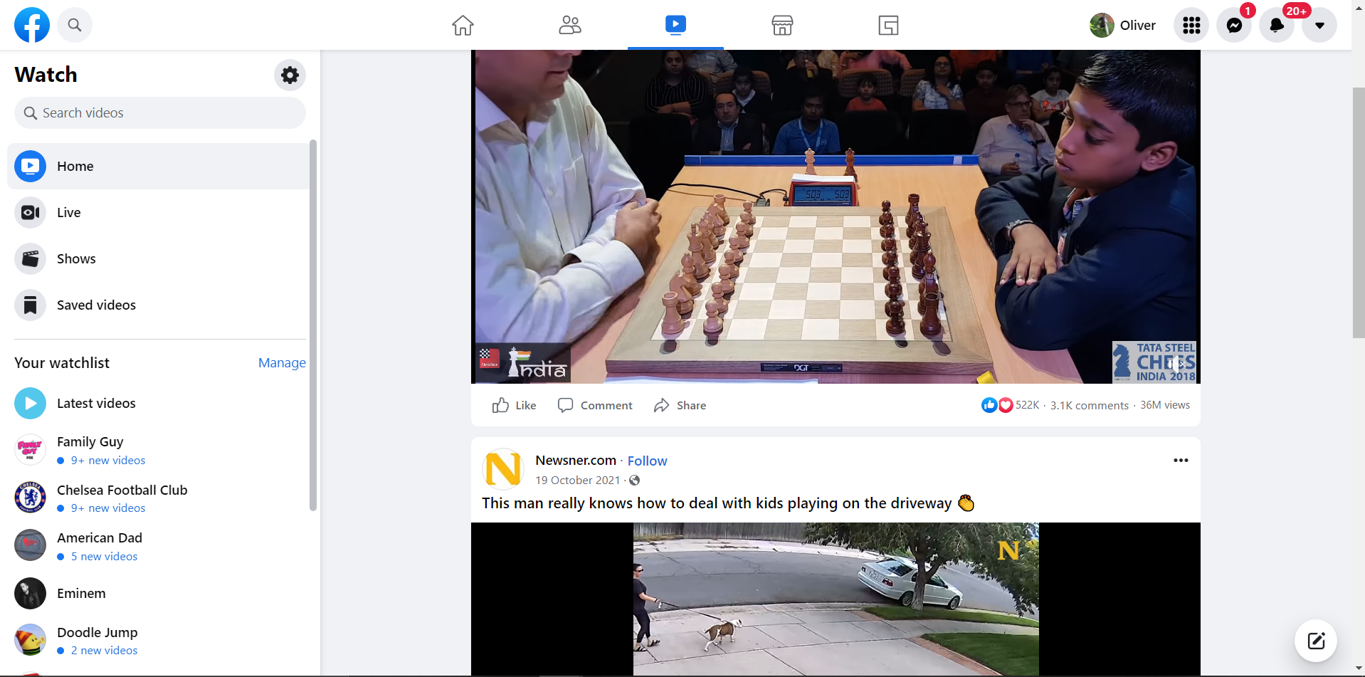

Even when switching to another tab, such as the videos side of the page, the style remains the same and the layout consistently used across it. The shortcuts on the left side remain separated from the centred media content which utilises white space in order for a clean and pristine appearance with a minimalistic style.

# Bibliography

Facebook. (2022, February 3). *Facebook*. Retrieved from Facebook: https://www.facebook.com/help/210310575676558

Statista Research Department. (2022). *Statista*. Retrieved February 1, 2022, from https://www.statista.com/statistics/272014/global-social-networks-ranked-by-number-of-users/